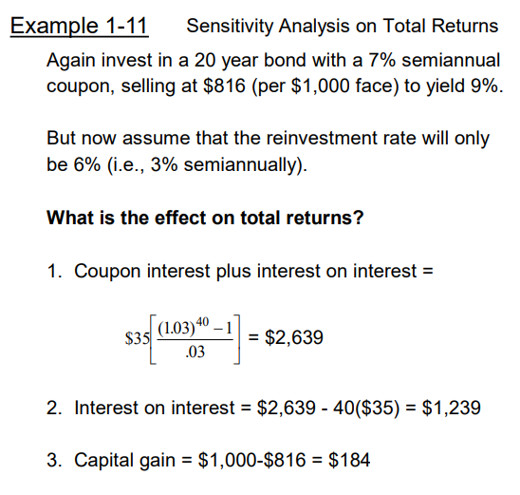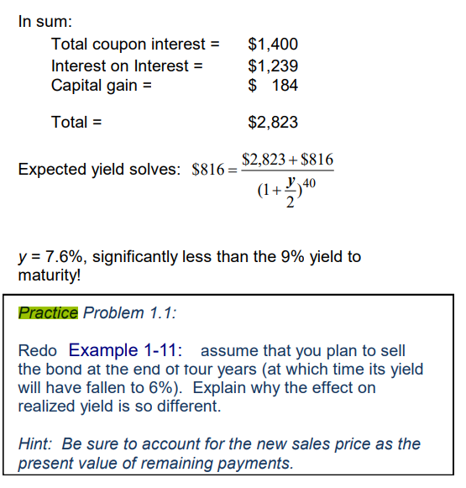

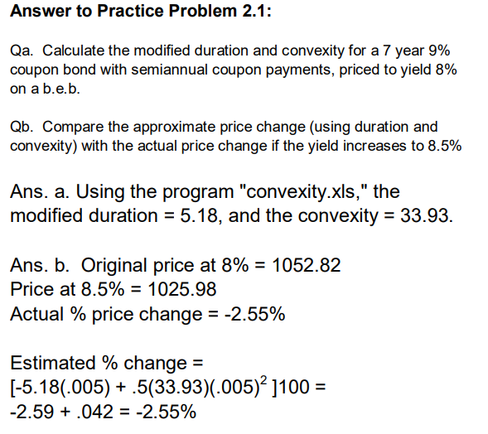



Duration -> calculate CFs, Value at year 10

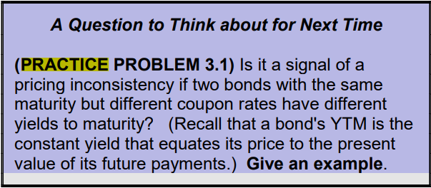

It is not, rate upward sloping + smaller coupon (larger proportion of payments falling in last year) = higher YTM

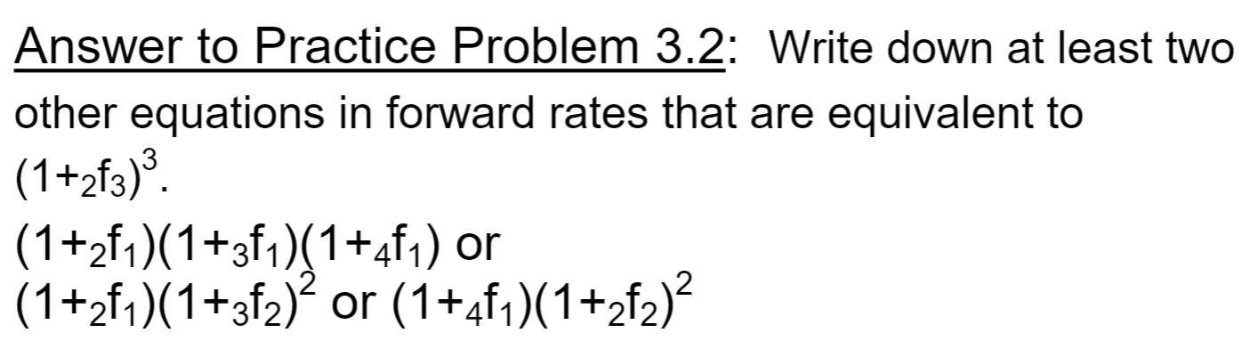

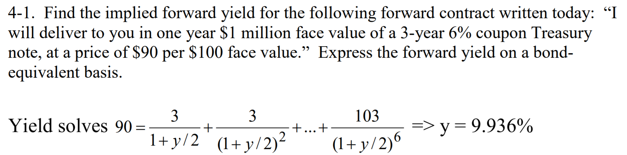

forward yield: yield during the period of contract

The rate “locked in”

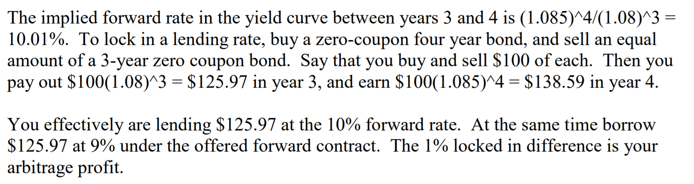

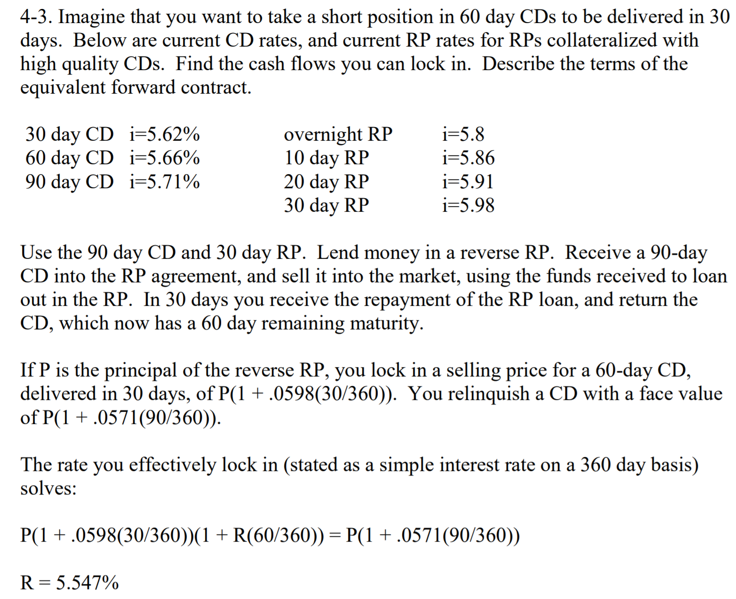

Short CD: sell CD at day 30, so you want to receive CD now, lend money in RP market

Principal of RP and CD at day 0: P

Selling price of CD / RP repayement = P\*RP rate

Face Value of CD / Future Cash Flow = P\*CD rate

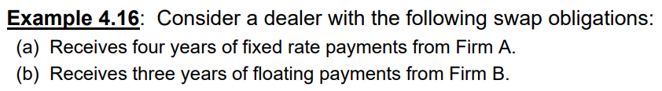

Four year Swap: At year four, company receives fixed rate payment but pays floating rate, so is exposed to rising (floating) rate. Short a forward interest rate contract (remember falling rate is in favor of long side)